Cafeteria Sales Analysis
CORRELATION:-
Quantity Price Per Unit
Quantity 1.000000 0.036427
Price Per Unit 0.036427 1.000000
Correlation analysis was performed between Quantity and Price Per Unit.
The correlation value (0.036) is close to zero, indicating that no s correlation exists between these variables.

INSIGHTS:-
- Coffee and snacks are top-selling items.
- Sales are concentrated on a few popular items.
- Customers are not highly price-sensitive.
- Uneven demand across items.
- Revenue is driven mainly by quantity sold.
STRATERGIES:-
- Promote combo offers on best-selling items.
- Improve digital payment adoption.
- Optimize pricing strategy.
- Rationalize the menu.
- Focus on volume-based promotions.

BAR GRAPH PLOT:-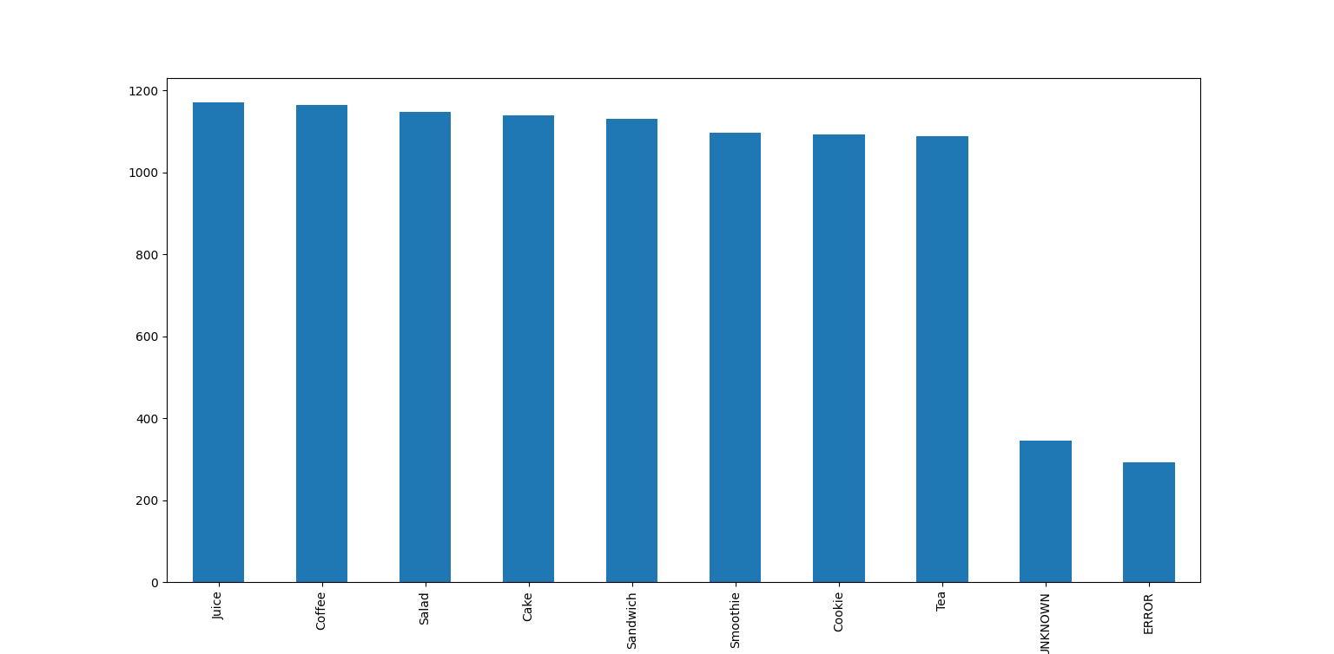
ITEM SALES DISTRIBUTION

